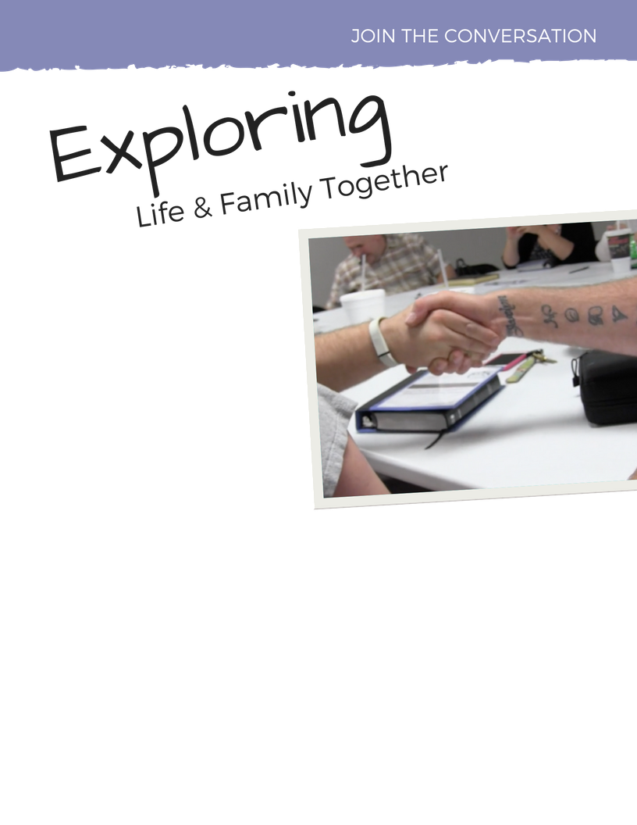

Join Us!

[Insert information about training and/or group meeting times here.]

Have questions about:

Your identity?

Making decisions?

Your relationships?

Do you think it might be time to do something differently? Are you ready to decide for yourself what’s important?

Find Encouragement. Be Inspired. Experience Change.

Join the conversation and meet others exploring life and family just like you!